CML Audio Player

Low Level Design

AllGo Embedded Systems Pvt Ltd
© Copyright 2015

Version History
Version Number | Date | Author(s) | Remarks
0.1 | 06/08/2019 | Ankit Raj,Aishwarya M,Roshini Taj | Initial version
0.2 | 16/08/2019 | Ankit Raj,Aishwarya M,Roshini Taj | Added shuffle algorithm,added performance and functional design,added APIs and file structures.
0.3 | 22/08/2019 | Ankit Raj,AishwaryaM,Roshini Taj | Updated sequence diagram after peer review

Table of Contents
1 Introduction 4
1.1 Purpose 4
2 Overview of the System 4
2.1 Definitions and Acronyms 4
3 References 4
4 Low Level Architecture 5
4.1 Application 6
4.2 CML AudioPlayer API 6
4.3 ALSA 7
4.4 File system 7
4.5 Performance Design 7
4.6 Functional Design 7
5 Sequence Diagram 7
5.1 Intialisation of CML AudioPlayer sequence diagram 8
5.2 Play, pause and stop sequence diagram 9
5.3 Next and Prev. sequence diagram 10
5.4 Seek control sequence diagram 11
5.5 Volume control sequence diagram 12
5.6 Shuffle Algorithm: 13
6 CML AudioPlayer API interfaces 13
6.1 File Structure 17
7 State Machine Diagram 18
8 Limitation 19
9 Traceability 19
10 Platform Dependencies 22

Introduction
This document explains the low level design for the CML AudioPlayer to be developed to play the uncompressed PCM file for the fullfilment of Induction Training Program at Allgo Embedded System(ITP-19).

Purpose
The purpose of this document is to provide a detailed description of the low level design for CML AudioPlayer. This document describes the detailed design of the modules,the architecture of the software, the sequence diagram and the state diagram .

Overview of the System
The CML AudioPlayer is the command line audio player and plays only wav files,which uses ALSA library to provide playback control and basic audio player functionality to the user.

Definitions and Acronyms
Sl.No. | Terms | Definitions
1 | WAV | Waveform Audio File format
2 | OS | Operating System
3 | ALSA | Advanced Linux Sound Architecture
4 | PCM | Pulse Code Modulation
5 | API | Application Programming Interface

References
This section covers the references followed for the CML AudioPlayer
- SRS-CML_AudioPlayer_SRSv0.3.doc
- Allgo Coding Guidelines
- ALSA project - the C library reference

Low Level Architecture
The Proposed CML AudioPlayer will have the following modules for the implementations of the functionality required.
- Application
- CML AudioPlayer API
- ALSA API

Below Figure represents the architecture of the CML AudioPlayer.

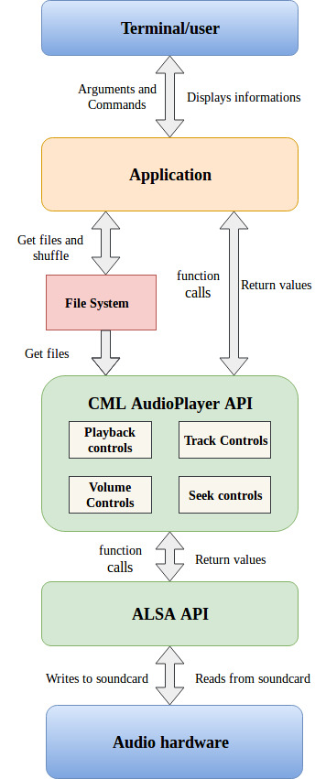

Application
The Application interfaces with the CML AudioPlayer library to achieve playback of the audio file and control. This module will be responsible for the following :
- Accept user input(WAV file(s) or playlist text file(s)) from the terminal.
- Set parameters required for CML AudioPlayer API intialisation.
- Provide necessary playback control to the user.
- Display currently playing audio file information

CML AudioPlayer API
CML AudioPlayer interfaces with the ALSA API and Application . It provides the Application module with the basic API needed for the control of the audio file required by the user .This module is responsible for the implementation of following Functionality.
Playlist creation:This module will create its own playlist of wav files given as input by the user.
Pause/Resume: This Functionality is used when “P” or “p” is pressed by user and Application calls corresponding API and is used to Pause/Resume the playback.
Stop:This Functionality is used when “S” or “s” is pressed by the user and Application calls corresponding API and stops the playback.
Play: This Functionality is used when “W” or “w” is pressed by the user and Application calls corresponding API to play audio after stopping playback.
Volume control: This Functionality is used when “+” or “-” is pressed by the user and Application calls corresponding API to increase/decrease the volume.
Seek Control:This Functionality is used when “F” or “G” or “J<mm:ss>” is pressed by the user and Application calls corresponding API to seek forward and backward by 10 sec and to seek to a particular time jump.
Next: This Functionality is used when “N” or “n” is pressed by the user and Application calls corresponding API to play next audio file.
Prev: This Functionality is used when “B” or “b” is pressed by the user and Application calls corresponding API to play previous audio file.
Shuffle: This Functionality is used when “-r” or “-R” is given as input through command line.which will shuffle all the files in playlist in random order.
Check File and input validation:CML AudioPlayer will also be responsible for the validation of arguments and input validation of input file type i.e. .wav or .txt.
Extract header: it will be also its task to obtain WAV file header information from the file taken from file system.

ALSA
ALSA is a software framework and part of the Linux kernel that provides an API for sound card device drivers. It is used to interface with the target audio hardware/PCM device for audio playback.The ALSA Library package contains the ALSA library used by programs requiring access to the ALSA sound interface. ALSA-lib contains the user space library used for compiling ALSA applications.The ALSA System on Chip layer is used to provide better ALSA support for embedded system-on-chip processors and portable audio codecs.ALSA-driver contains the ALSA components that run in kernel space

File system
File System here is responsible for storing all the wave files present in the playlist or passed as the arguments.All the audio files is stored and present in file system.

Performance Design
The CML AudioPlayer design uses multithreading. The CML AudioPlayer API handles the playing and control of the audio file and the Application handles the functionality requests from the user.
- The CML AudioPlayer APIs must perform the required function within 100ms of being called.
- The CML AudioPlayer must start playback within 100ms of starting the player,if not the CML AudioPlayer must exit.
- The CML AudioPlayer must generate the internal play-list within 100ms.

Functional Design
The implementation of the CML AudioPlayer API will consist of two threads for parallel processing.The following threads will be running in parallel and will be performing the respective functionalities:
- Playback thread : which will be for the playback the audio files
- Control Thread: which will be responsible for the providing user the control of playback.

5 Sequence Diagram
Shown below is the sequence diagram of CML AudioPlayer which illustrates the various modules and interaction between them.

5.1 Intialisation of CML AudioPlayer sequence diagram
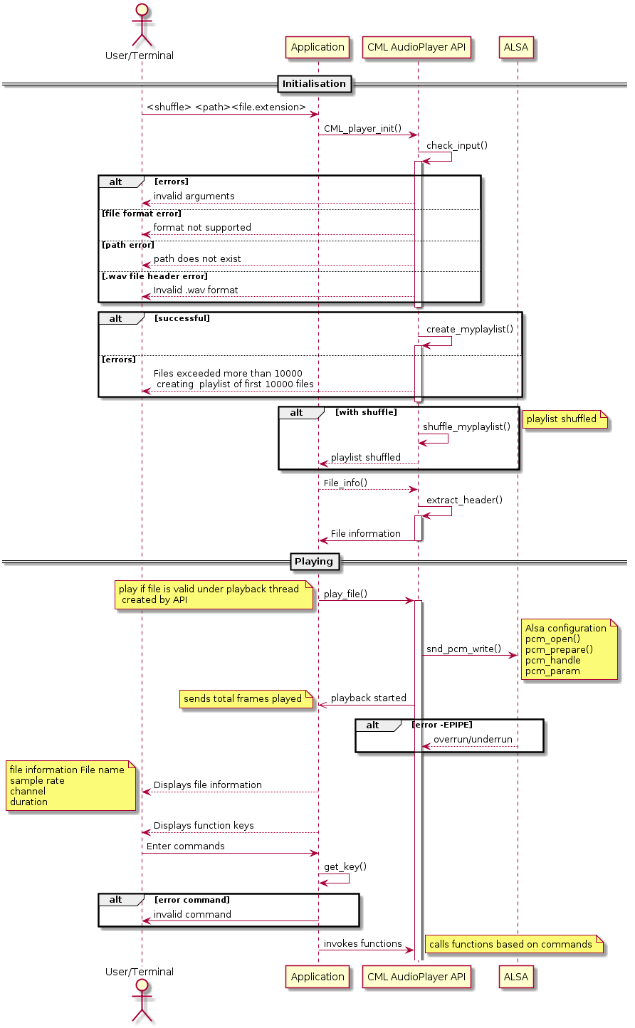

Fig:shows Cml_Audioplayer initializes the play-back.

5.2 Play, pause and stop sequence diagram
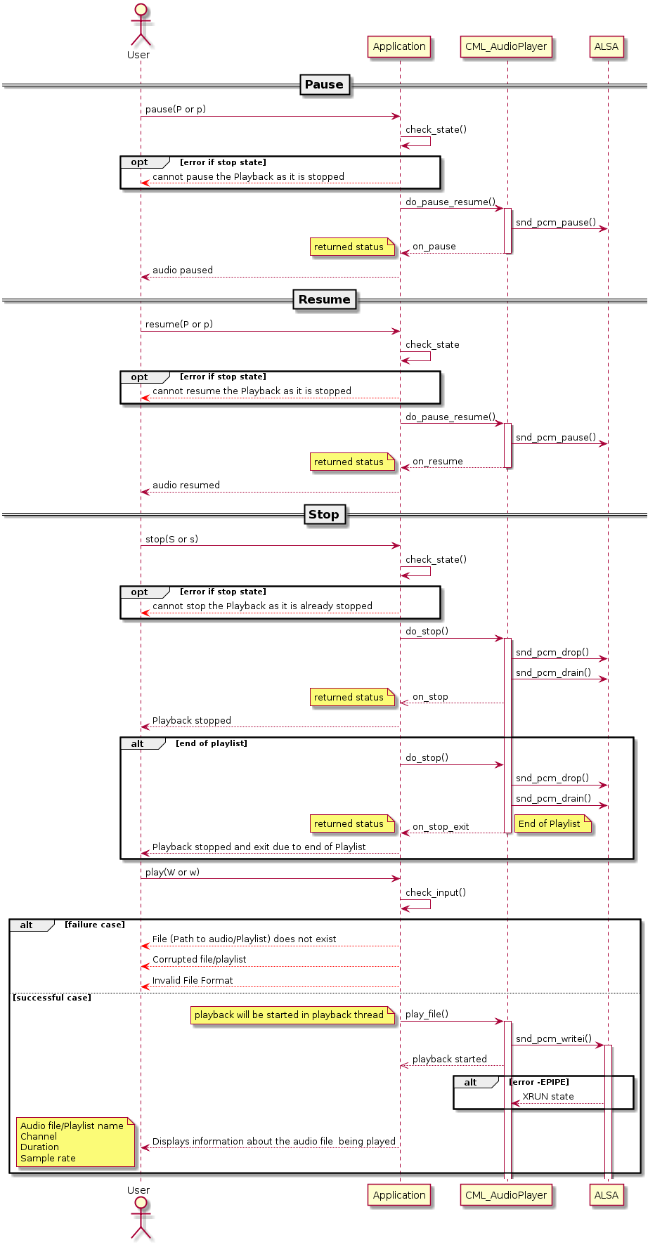
Fig:shows playback control by Cml_AudioPlayer.

5.3 Next and Prev. sequence diagram
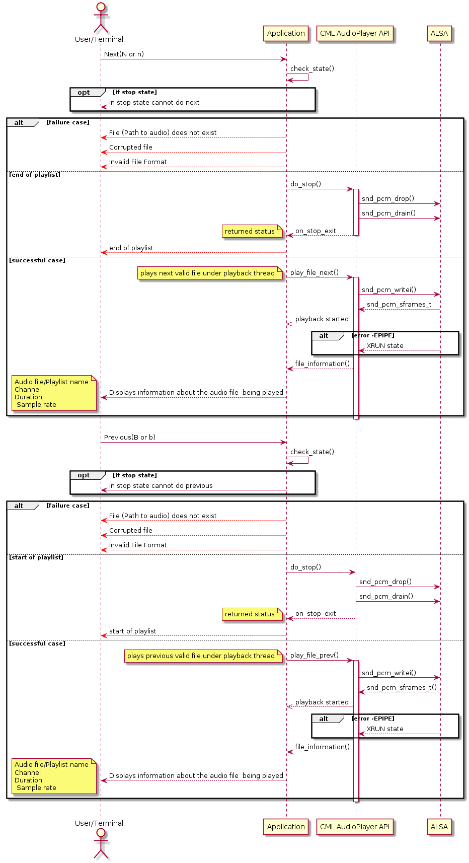

Fig:shows track control by cml_Audioplayer.

5.4 Seek control sequence diagram
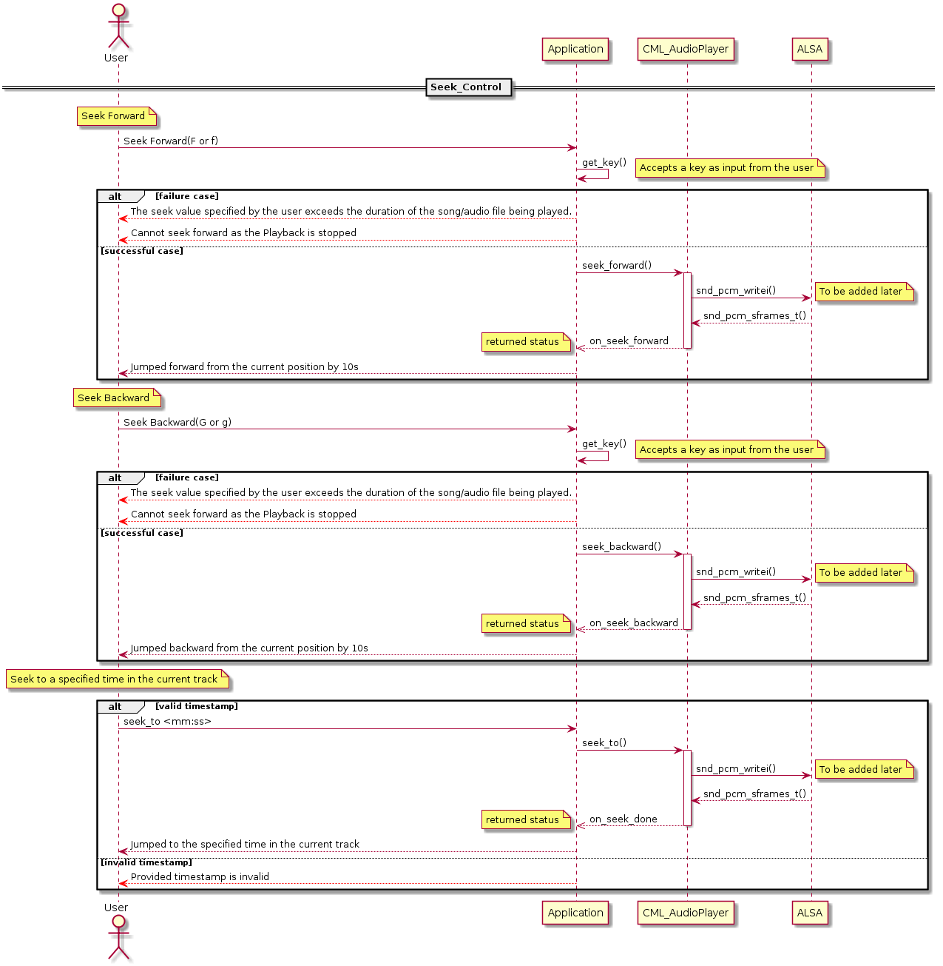
Fig:shows the seek_control by cml_AudioPlayer

5.5 Volume control sequence diagram

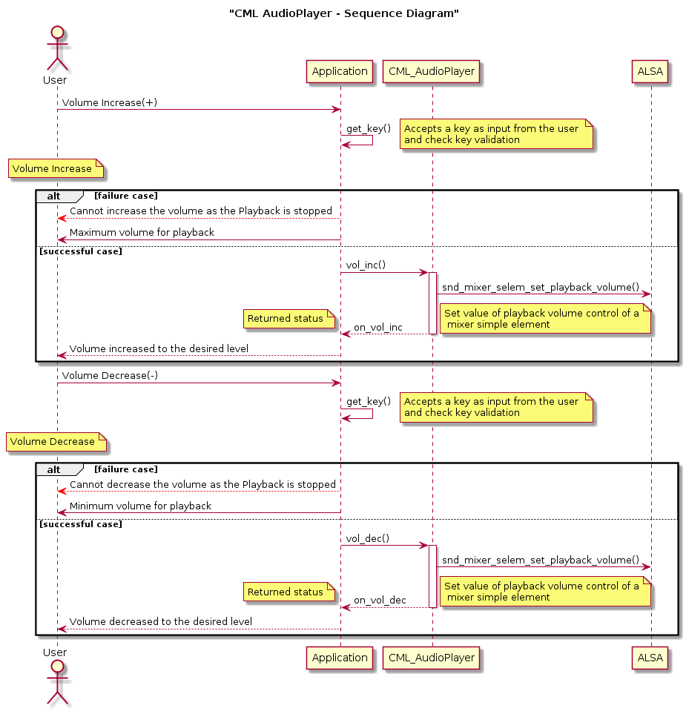

Fig:shows volume control by cml_AudioPlayer

5.6 Shuffle Algorithm:
The basic method given for shuffling the order of the .wav files from 1 through N (i.e the total no. of .wav files) goes as follows:

1) Read all the files from 1 through N.

2)Generate a random number k between one and the number of unstruck files remaining (inclusive) by using srand(time(NULL)).

The srand(time(NULL)) function makes use of the computer's internal clock to control the choice of the seed. Since time is continually changing, the seed is forever changing.

3)A utility function is used to swap the files one by one (starting from the last .wav file in the Playlist) with the file at random index.

Counting from the low end i.e the last .wav file in the internally generated Playlist, strike out the kth file not yet struck out, and write it down at the end of a separate list (.txt file).

4)Repeat from step 2) until all the files have been struck out.

5)The sequence of files written down in step 3) is now a random permutation of the original files which is nothing but the shuffled playlist.

6 CML AudioPlayer API interfaces

status cml_audioplayer_init(int argc, char *argv[])
Description: This API initializes the PCM device,sets the parameters and creates the play-list

Returns status
The following Error codes are returned :
INIT_SUCCESS - This is returned on successful execution of API
INIT_FILE(S)_NOT_FOUND - returned if file(s) are not found

status cml_audioplayer_play(char *filename[ ])
Description: This API fetches the file handle of the first file in the internal play-list and starts the playback

Returns status
PLAY_SUCCESS:0
ON failure it returns -EPIPE

status cml_audioplayer_pause_resume(int val)
Description: This API toggles the playback between pause and resume depending on the val being sent.

Returns status
The following Error codes are returned :
PR_SUCCESS - This is returned on successful execution of API
PR_ON_FAILURE :audio cannot paused.

status cml_audioplayer_volume_control(long val)
Description: This API increases or decreases the volume depending on the key pressed by the user..

Returns status
The following Error codes are returned :
V_SUCCESS - This is returned on successful execution of API
V_UNDERFLOW - returned if volume decreased below 10%
V_OVERFLOW – returned if volume increased above 100%

status cml_audioplayer_play_next_file(char *curfilename[] )
Description: This API jumps the play-back to the next track in the play-list

Returns status
The following Error codes are returned :
PN_SUCCESS - This is returned on successful execution of API
PN_ENDOF_PLAYLIST - returned if the play-back is at the end of the play-list

status cml_audioplayer_play_prev_file(char *curfilename[] )
Description: This API jumps the play-back to the previous track in the play-list

Returns status
The following Error codes are returned :
PP_ WAV_SUCCESS - This is returned on successful execution of API PP_BEGINOF_PLAYLIST - returned if the play-back is at the beginning of the play-list

status cml_audioplayer_seek_forward( )
Description: This API seeks the play-back forward.

Returns status
The following Error codes are returned :
SF_SUCCESS - This is returned on successful execution of A
SF_ REACHED_EOF - returned if the play-back is at the end of audio

status cml_audioplayer_seek_back()
Description: This API seeks the play-back backward.

Returns status
The following Error codes are returned :
SB_SUCCESS - This is returned on successful execution of API
SB_STARTOF_AUDIO - returned if the play-back is at the beginning of audio

status cml_audioplayer_seek_to(int sec )
Description: This API seeks the play-back to the particular time-stamp given by sec.
Returns status
The following Error codes are returned :
ST_SUCCESS - This is returned on successful execution of API
ST_INVALID_TIME - returned if a invalid time-stamp is entered

status cml_audioplayer _playback_stop( )
Description: This API stops the play-back,clears the buffer,closes the device and cancel the playback_thread

Returns status
The following Error codes are returned :
S_SUCCESS - This is returned on successful execution of API

status cml_audioplayer_checkInput (int argc,char*argv[])
Description: this API checks the input entered by the user based on that it will return the following status

Return status
The following status Code is returned
CI_SUCCESS-This is returned on valid inputs.
On Invalid cases it will return the following error codes

enum eci_status {
“SUCCESS”=CI0,
”INVALID FILE_EXTENSION”,
”INVALID PLAY LIST_EXTENSION”,
INVALID KEY_FOR_SHUFFLE”,
”EMPTY_PATH”,”CORRUPTED_FILES”
}

status cml_audioplayer_shuffle(struct *f)
Description:This API randomly shuffle myplaylist

Return Status:
SHUFFLE_SUCCESS:it will return 0
CANNOT_SHUFFLE:it will return 1

status cml_audioplayer_create_playlist(int argc,char *argv[])
Description:This API will create internal playlist.

Return status:

CREATED_MYPLAYLIST
UNABLE_TO_CREATE_MYPLAYLIST

status cml_audioplayer_get_key()
Description:This API will get the input key from commandline.

Return status:
KEY_SUCCESS-on successfully getting the input key.
INVALID_KEY-API will unable to get the key.

status cml_audioplayer_header_info(struct *f)
Description:This API will get the header information 0f the .wav file.

Return status
*HEADER-it will return pointer to .wave file header
CANNOT_FETCH_FILE_INFO-if file is corrupted.

status cml_audioplayer_check_state();

6.1 File Structure

inc
- CML_AudioPlayer.h

src
- CML_AudioPlayer.c
- wave_header.c

interface_headers
- CML_AudioPlayer_types.h
- CML_AudioPlayer_defines.h
- CML_AudioPlayer_error_codes.h
- CML_AudioPlayer_interface.h

build
- Makefile

7 State Machine Diagram
The State Machine diagram of CML AudioPlayer consists of five states : Play, Pause, Next, Previous and Stop.

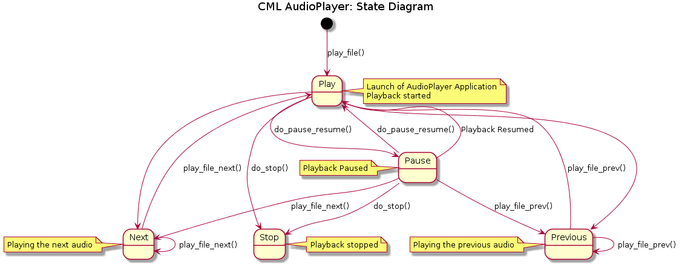

Description of state Diagram:
The Playback starts when the AudioPlayer is launched.
- PLAY: when AudioFile is playing.
- PAUSE: when AudioFile is stopped at a particular point.
- RESUME: when AudioFile is resumed from the point it was paused.
- STOP: when AudioFile is stopped from being played.
- NEXT: when AudioFile Forwarded in time.
- PREVIOUS: when AudioFile is Rewinded.
ESC key can be pressed from any of the states to exit the application

8 Limitation
- When the volume is increased beyond the threshold value there will be deterioration in audio quality.
- User can’t shuffle the song during run time of the program.
- CML AudioPlayer only plays .wav file.

9 Traceability
Section contains all the requirement mapping.

S.no | Requirement ID | Design Document Section | Status | Comments
 | File_1 | LLD_4.1 | Supported
 | File_2 | LLD_4.1 | Supported
 | Aud_1 | LLD_4.5 | Supported
 | Aud_2 | LLD_4.2 | Supported
 | Aud_3 | LLD_4.4 | Supported
 | Aud_4 | LLD_4.4 | Supported
 | Aud_5 | LLD_4.4 | Supported
 | Aud_6 | LLD_4.1,LLD_4.2 | Supported
 | Aud_7 | LLD_4.2 | Supported
 | Aud_9 | LLD_4.1 | Supported
 | Aud_1 | LLD_4.3 | Supported
 | Aud_12 | LLD_4.3 | Supported
 | KEY_1 | LLD_4.5 | Supported
 | KEY_2 | LLD_4.5 | Supported
 | KEY_3 | LLD_4.1 | Supported
 | KEY_4 | LLD_4.2 | Supported
 | KEY_5 | LLD_4.2 | Supported
 | KEY_6 | LLD_4.2 | Supported
 | KEY_7 | LLD_4.3 | Supported
 | KEY_8 | LLD_4.3 | Supported
 | KEY_9 | LLD_4.1 | Supported
 | KEY_10 | LLD_4.4 | Supported
 | KEY_11 | LLD_4.4 | Supported
 | KEY_12 | LLD_4.4 | Supported
 | REQ_01 | LLD_6 | Supported
 | REQ_02 | LLD_6 | Supported
 | REQ_03 | LLD_6 | Supported
 | REQ_04 | LLD_6 | Supported
 | REQ_05 | LLD_6 | Supported
 | REQ_06 | LLD_6 | Supported
 | REQ_07 | LLD_6 | Supported
 | REQ_08 | LLD_6 | Supported
 | REQ_09 | LLD_6 | Supported
 | REQ_10 | LLD_6 | Supported
 | REQ_11 | LLD_6 | Supported
 | REQ_12 | LLD_6 | Supported
 | REQ_13 | LLD_6 | Supported
 | REQ_14 | LLD_6 | Supported
 | REQ_15 | LLD_6 | Supported
 | REQ_16 | LLD_6 | Supported
 | REQ_17 | LLD_6 | Supported
 | REQ_18 | LLD_6 | Supported
 | REQ_19 | LLD_6 | Supported
 | REQ_20 | LLD_6 | Supported
 | REQ_21 | LLD_6 | Supported
 | REQ_23 | LLD_6 | Supported
 | REQ_24 | LLD_6 | Supported
 | REQ_25 | LLD_6 | Supported
 | REQ_26 | LLD_6 | Supported
 | REQ_27 | LLD_6 | Supported
 | D_01 | LLD_4.1 | Supported
 | D_02 | LLD_4.1 | Supported
 | D_03 | LLD_4.1 | Supported
 | D_04 | LLD_4.1 | Supported
 | D_08 | LLD_4.2 | Supported
 | D_09 | LLD_4.2 | Supported
 | AG_1 | LLD_4.1 | Supported
 | AG_2 | LLD_4.1 | Supported
 | AG_3 | LLD_4.1 | Supported
 | AG_4 | LLD_4.1 | Supported
 | AG_5 | LLD_4.1 | Supported
 | AG_6 | LLD_4.1 | Supported
 | AG_7 | LLD_4.1 | Supported
 | AG_8 | LLD_4.1 | Supported
 | PL_01 | LLD_4.1 | Supported
 | PL_02 | LLD_4.1 | Supported
 | PL_03 | LLD_4.1 | Supported
 | PL_05 | LLD_4.1 | Supported
 | PL_06 | LLD_4.1 | Supported
 | PL_07 | LLD_4.1 | Supported
 | PL_08 | LLD_4.1 | Supported
 | PL_09 | LLD_4.1 | Supported
 | PL_10 | LLD_4.1 | Supported
 | Pl_11 | LLD_4.1 | Supported
 | FF_1 | LLD_4.1 | Supported
 | FF_2 | LLD_4.1 | Supported
 | FF_3 | LLD_4.1 | Supported
 | FF_4 | LLD_4.1 | Supported
 | FF_5 | LLD_4.1 | Supported
 | FF_6 | LLD_4.1 | Supported
 | FF_7 | LLD_4.1 | Supported
 | ERR_01 | LLD_4.1 | Supported
 | ERR_02 | LLD_4.1 | Supported
 | ERR_03 | LLD_4.4 | Supported
 | ERR_04 | LLD_4.2 | Supported
 | ERR_05 | LLD_4.2 | Supported
 | ERR_06 | LLD_4.1 | Supported
 | ERR_07 | LLD_4.4 | Supported
 | ERR_08 | LLD_4.1 | Supported
 | ERR_09 | LLD_4.1 | Supported
 | ERR_10 | LLD_4.1 | Supported

10 Platform Dependencies

SL.No. | Platform/Category | Details/Description
1. | Player Framework | ALSA, 2 Channels(Mono and Stereo)
2. | Supporting OS  for Playlist | Linux
3. | PCM Stream | Playback

